Impact of Ion Transport on Membrane Scaling in Bipolar Membrane Electrodialysis

*Author Names: Yuqin Nia,b, She Qianhonga,b*

Author Address:

1. School of Civil and Environmental Engineering, Nanyang Technological University, Singapore 639798, Singapore
2. Singapore Membrane Technology Centre, Nanyang Environment & Water Research Institute, Nanyang Technological University, Singapore 637141, Singapore

**Abstract**

Bipolar membrane electrodialysis (BMED) is an emerging technology for producing acid and base from salt solutions. However, the presence of divalent cations, such as Ca2+ and Mg2+, can lead to scaling through reactions with hydroxide ions (OH-), posing a significant operational challenge. This study provides a mechanistic understanding of scaling formation in BMED systems treating seawater brine. Scaling was observed in multiple locations, including the chambers and on bipolar membrane (BPM) and both sides of the cation exchange membrane (CEM). Initially, divalent cations migrated through the CEM and reacted with excess OH⁻ in the base chamber (BC), resulting in scale formation on the CEM facing BC. The accumulated scaling reduced the effective membrane area, increasing the local current density. Once the local current density exceeded the limiting current density, water splitting was triggered, generating additional OH-. OH- leaked into the seawater brine chamber (SWBC), where further water splitting and scaling occurred on the CEM facing the SWBC. In addition, scaling on BPM was attributed to the interaction between divalent cations and the locally elevated OH- concentration. These findings elucidate the evolution of scaling in BMED and provide insights for its mitigation in brine treatment applications.

**Keywords**

Bipolar membrane electrodialysis (BMED); Seawater brine treatment; Scaling formation

1. **Introduction**

In conventional chemical processes, high-salinity wastewater often arises as a byproduct of acid-base neutralization reactions. The direct discharge of brine solutions not only damages the environment1-3 but also leads to the loss of valuable resources2, 4-6. Therefore, the effective treatment of such waste brine solutions has become an urgent and critical issue. Among various treatment methods, electrodialysis (ED) has been widely employed to concentrate brine solutions, facilitating subsequent crystallization into solid salts 7-9. However, the economic viability of salt recovery via ED is not always favorable 10. To address this limitation, bipolar membrane electrodialysis (BMED) has been developed as an advanced electrochemical separation technology that combines the principles of ED with the unique properties of bipolar membranes (BPMs) 10-13. This approach enables the production of acids and bases from salt solutions, providing an efficient and environmentally sustainable alternative to conventional chemical processes. BMED has been applied in various biological and chemical industries 14-17. Many studies have shown that BMED has the potential to produce high-purity acids (e.g., HF,18 HNO310, HCl19, H2SO420, H3PO421, acetic acid22, citric acid23) and bases (e.g., NaOH21, 24, LiOH19) from salt solutions.

One of the most critical challenges in BMED is the formation of scaling on ion exchange membranes (IEMs) 25, 26. Scaling adversely affects BMED by reducing ion flux, increasing membrane resistance, and elevating energy consumption26-28. As scaling progresses, it can cause irreversible damage to membranes, especially increasing the risk of membrane rupture 29. Generally, scaling is affected by solution composition, process parameters and IEM properties. Bazinet, et al. 30 and Wang, Yang and Cong 27 found scaling on cation exchange membranes (CEMs) when feeding solution contained Ca2+ and Mg2+. Casademont, et al. 31 found that an alkali feeding solution triggered scaling on CEMs. The presence of multivalent ions (e.g., Ca2+ and Mg2+) in feeding solution predominantly results in scaling as they react with hydroxide ions (OH⁻) within the chambers to form sparingly soluble precipitates 25-27, 30. Many other studies studied the process parameters, such as flow rate32 and current density32, 33. A high flow rate can enhance mixing near membrane/solution interface to avoid ion accumulation. In terms of current density, it is related to ion flux, which causes pH shifts near membrane surface and scaling growth. Some studies link the scaling behavior with properties of IEMs, including ion selectivity14, heterogeneity34, 35, and membrane roughness35, 36. These studies tried to change surface properties of membranes to avoid scaling accumulation.

Scaling in BMED is an unavoidable problem because of the presence of base chamber. Previous studies have primarily focused on removing divalent ions prior to BMED treatment using pretreatment such as nanofiltration37, chemical precipitation37, ion exchange resins 19, pellet reactor 26. While these strategies reduced the incidence of scaling, they often introduce additional complexity and cost. Moreover, they do not consider that more efficient methods can be designed according to scaling mechanisms on different location. Therefore, a mechanistic understanding of how scaling evolves—particularly how ion transport behaviors interact with scaling processes—needs to be explored. Currently, no studies have provided a comprehensive analysis of the precipitation sequence in different chambers and on the IEMs.

The objective of this study is to elucidate the mechanism of scaling formation throughout the BMED process, with a focus on the interactions between ion transport and scaling development. The influence of scaling on BMED performance and efficiency was discussed to explain the significance of the study. The scaling in the chamber and on IEMs was characterized to ensure the location where scaling took place and its composition. In the BMED process, the system parameters were monitored to explain the scaling evolution. By providing a mechanistic framework, this study offers insights into future strategies for effective mitigation and operational optimization.

1. **Material and Methods**
   1. **Lab-scale BMED Stack and Membranes**

Commercial ion exchange membranes (IEMs) were used in this study. The bipolar membranes (BPMs) were CJBPM-1 (Kejia Polymer Materials Technology Co., China), while the CEMs and anion exchange membranes (AEMs) were CSE and ASE, respectively (ASTOM Co., Japan). All membranes were cut to dimensions of 5 cm × 5 cm, yielding an effective membrane area of 7.065 cm2.

The configuration of the lab-scale BMED stack was illustrated in **Figure 1**. The stack contained three repeating units, each consisting of one BPM, one AEM, and one CEM. An additional BPM was placed adjacent to the cathode to maintain symmetry. The complete assembly comprised two electrode chambers (ECs), three acid chambers (ACs), three seawater brine chambers (SWBCs), and three base chambers (BCs). Each chamber had a thickness of 1 cm.

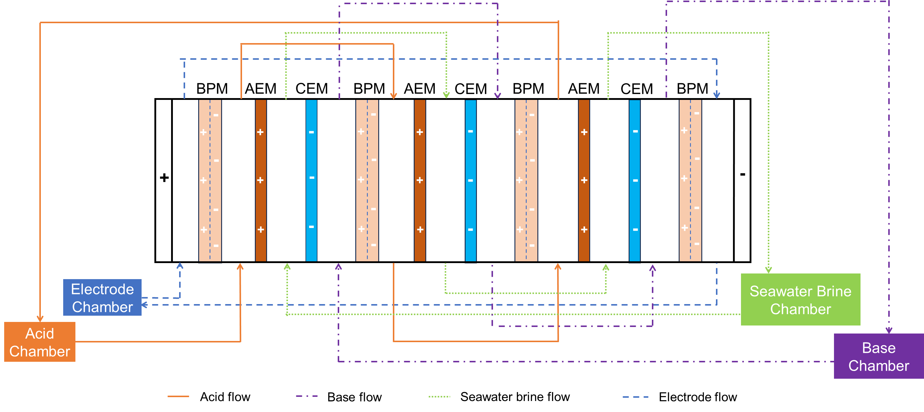

Figure 1 The configuration of lab-scale experimental BMED stack.

* 1. **Protocol**

A closed-loop circulation system was employed due to the low current density used in the experiments38.

The setup consisted of four independent solution circuits: salt solution, base solution, acid solution, and electrode rinsing solution. The seawater brine (SWB) was prepared by doubling the concentration of synthetic seawater39, with the detailed composition provided in **Table S1**. For comparison, a NaCl solution with equivalent conductivity to the SWB was used as a baseline system to examine BMED performance in the absence of scaling. The BC and AC were filled with 10 mM NaOH and 10 mM HCl, respectively. The electrode rinsing solution was 0.3 M Na2SO4. The volume of each solution was 0.4 L. Two peristaltic pumps (Lead Fluid, BT-600L-2 × YT15, China) maintained a constant flow rate of 200 mL/min through the respective chambers. Titanium electrodes coated with ruthenium served as the anode and cathode. A constant current mode was adopted to ensure higher acid/base production rates and improved ion permselectivity 40. The applied current density was maintained at 15 mA/cm² using a DC power supply (A-BF SS-L603SPD, China). Each experimental run lasted for 9 hours and was repeated at least three times to ensure reproducibility.

Prior to applying the current, the system was operated for 10 minutes to remove air bubbles, ensuring complete wetting of the membrane surfaces and minimizing potential performance disturbances.

* 1. **Scaling Characterization and BMED Performance Analysis**
     1. **BMED Performance Analysis**

Key operational parameters—including voltage, current, and pH—were continuously monitored to assess BMED performance and ensure system stability. Conductivity changes in AC, BC and SWBC were recorded every five minutes using conductivity meters (Orion Star A212, Thermo Scientific, USA). Current and voltage data were recorded every minute using Power DC software. The pH in the AC, BC, and SWBC was measured using a portable pH meter (Seven2Go pH/Ion Meter S8, Mettler Toledo, Singapore). Additionally, 0.5 mL samples were periodically collected from each chamber to quantify the concentration of divalent ions (i.e., Ca²⁺ and Mg²⁺) using inductively coupled plasma optical emission spectroscopy (ICP-OES, Vio 550Max, PerkinElmer).

The stack resistance ($R_{stack}$, Ω) was calculated according to Ohm’s Law with Eq. 1.

$$\begin{aligned}R_{stack}=\frac{U_{t}}{I_{t}}\#\left(1\right)\end{aligned}$$

Where $U_{t}$ was the voltage (V) and $I_{t}$ was the current (A) at time $t$.

The stack resistance is the sum of electrode resistance, chamber resistance, and membrane resistance 39, 41. The electrode resistance ($R_{ele}$) was 43.11 Ω (details in **Supporting Information S2**). The chamber resistance ($R_{chamber}$, Ω) was calcualted by Eq. 241.

Where is the number of repeating units, $A$ is the effective membrane area (m2). , , were the thickness of AC, BC and SWBC (m), $σ_{AC}$, $σ_{BC}$ and $σ_{SWBC}$ is the conductivity of AC, BC and SWBC (S/m, **Fig. S3 and Fig. 2 a**).

The membrane resistance ($R_{membrane}$, Ω) was calculated by **Eq. 3**.

* + 1. **Scaling Characterization**

Characterizing membrane scaling was essential for visualizing deposits morphology and determining elemental composition. Scanning electron microscopy (SEM; JEOL-7200F, Japan) and energy-dispersive X-ray spectroscopy (EDS; Oxford Instruments Aztec Standard X-max 50) were employed to examine membrane surfaces. Additionally, precipitated solids collected after BMED operation were analyzed using X-ray diffraction (XRD; Bruker D8) to identify crystalline phases.

To assess the extent of scaling within the chambers, turbidity measurements were performed on the salt and base solutions. 30 mL of solution were sampled from the SWBC and BC both before and after the experiments. Turbidity was measured using a laboratory turbidimeter (2100N IS, HACH), with each sample analyzed in triplicate for accuracy.

In addition to qualitative characterization, quantitative analysis was conducted to evaluate scaling severity. The calcualtion of reduction ratio of Ca²⁺ and Mg²⁺ ($R_{{Ca}^{2+}}$, $R_{{Mg}^{2+}}$, %) and mass of scaling ($m_{scaling-Ca}$, $m_{scaling-Mg}$, mg) was shown in **Supporting Information S3**.

1. **Results and Discussion**
   1. **Influence of scaling on BMED performance and efficiency**

Scaling seriously affected the BMED performance. The desalination efficiency for SWB was slightly lower than that of NaCl (conductivity decreased by 16.65 % and 19.02% in 9 hours respectively) (**Fig. 2a**). Several factors contributed to this phenomenon. Firstly, SWB contained a mixture of salts and minerals. The presence of additional ions, such as Mg2+ and Ca2+, attributed to additional water transport because divalent ions had higher hydration number42. The volume of SWBC decreased and further decrease desalination efficiency of BMED36. Additionally, multivalent ions in SWB led to scaling, with precipitates like Mg(OH)2, Ca(OH)2 and CaCO3, forming on membrane surfaces. The scaling resulted in additional resistance to ion transport, further hindering the removal of ions. The acid and base conductivity was subsequently affected (**Fig. S3**). With a low conductivity in AC and BC, the voltage (**Fig. 2b**) and chamber resistance (**Fig. 2c**) was extremely high at the beginning of test. As BMED processed, the increase of acid and base conductivity resulted in the sharp decrease of chamber resistance and voltage. Although chamber resistance remained low (~21 Ω) after 1 hour, membrane resistance gradually increased and reached 226.71 Ω when treating SWB, which was 85.9% higher than that treating NaCl (~32.36 Ω) (**Fig. 2c**). The high membrane resistance also proved the presence of severe scaling on membranes, which resulted in the high voltage (~30 V) across BMED stack after 1 hour (**Fig. 2b**). Besides the resistance change, scaling also influenced the pH in SWBC (**Fig. 2d**). When treating SWB, pH increased from 7.65 to 9.74, while it decreased for NaCl tests (from 6.83 to 2.14). Because H+ had higher mobility43, it cannot be completely blocked by AEMs and leaked to SWBC to decrease pH. However, when processing SWB, the leaked H+ was completely consumed, indicating that additional OH- was generated. pH of SWBC was stable around 9.7 after 6 h because the solubility of Mg(OH)2 exceeded the solubility product constant in the bulk solution and scaling was formed in SWBC.

In addition to the influence on performance, scaling also decreased the efficiency.

**Fig. 2 e** illustrated the concentration of generated acid and base over time in the BMED system when treating NaCl and SWB, respectively. In the AC, the final concentration of generated acid for SWB was 170.74 ± 9.94 mM (210.03 ± 36.31 mM for NaCl). The difference in BC was more significant: the final concentration of generated base for SWB and NaCl was 115.10 ± 72.47 mM and 323.86 ± 57.97 mM, respectively. On generally, the concentration of generated acid was lower than that of base (35.15% for NaCl) because H+ leaked from AC to SWBC (**Fig. 2d**). However, scaling reduced the overall production efficiency. Divalent ions transported across CEM consumed part of OH- generated to for scaling, resulting in the lower base field (decreased by 37.9%). Moreover, the scaling on BPM reduce the transport of water to the bipolar junction and prevent water dissociation44, decreasing the generation of H+ and OH-. In that case, the acid production was affected as well. Besides, the transport of OH- from SWBC to AC might also decrease the acid concentration. Due to the presence of scaling, the specific energy consumption (SEC) (details in **Supporting Information Section S4**) increased significantly. SEC of BMED treating SWB was significantly higher than that treating NaCl (73.3% higher for acid and 92.7 % higher for base, **Fig. S4**). Scaling increased the voltage of the stack (**Fig. 2b**) and reduced the production of acid and base (**Fig. 2e**). This synergistic effect results in a significant increase in SEC.

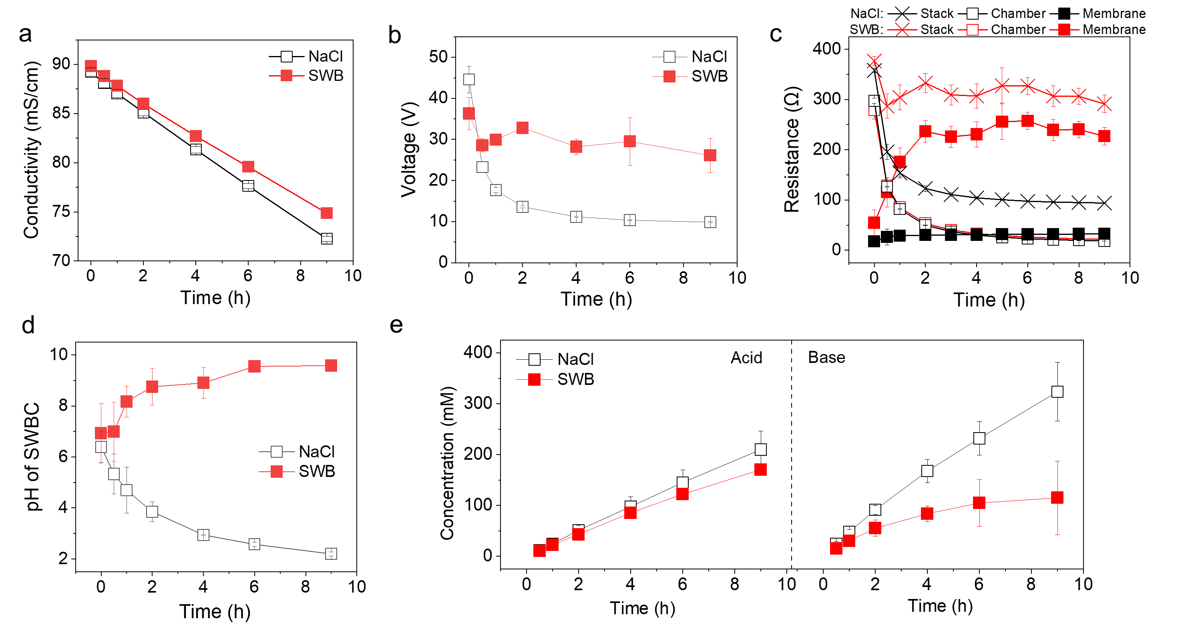

Figure 2 (a) Conductivity changes in SWBC; (b) Voltage changes across the BMED system; (c) Variation of stack resistance, chamber resistance and membrane resistance; (d) pH change in SWBC; (e) Concentration of generated acid and base during BMED treating different solutions (SWB, seawater brine; NaCl, the sodium chloride solution with the same conductivity as SWB).

The performance and efficiency decline indicated the severe scaling in BMED treating SWB. **Fig. S5** showed the results in the recycling test. The difference in voltage drop (**Fig. S5 a**) can be neglectable because NaCl solution was processed. However, the efficiency of BMED with scaled membrane decreased. The slowdown in the rate of conductivity decrease in SWBC indicates that ion transport was impaired (**Fig. S5 b**). The change of pH of SWBC (**Fig. S5 c**) also indicated that the OH- leakage of scaled membrane may increase, which will be discussed in detail when explaining the scaling on CEMs. The lower field of acid (decreased by 3.47% ) and alkali (decreased by 17.46%) (**Fig. S5 d**) also illustrated the irreversible decline of membrane properties in BMED. Therefore, scaling should be avoided in BMED stack. The following sections will systematically analyze the scaling forming at different locations in BMED stack.

* 1. **Characterization of scaling on different IEMs in BMED stack**

After BMED tests, IEMs and solutions were characterized to analyze the formation location and chemical composition. When treating NaCl, no precipitate was observed in the chambers (**Fig. S6 a1 a2**) or on the membrane (**Fig. 3 a1 b1 c1 d1**). However, there were suspended particles in the SWBC and BC (**Fig. S6 b1 b2**) and a significant amount of precipitates (**Fig. 3 b2 c2**) was observed on the IEMs.

Compared with tests for NaCl (**Fig. S6 a1 a2**), SWBC and BC became visibly turbid when processing SWB **(Fig. S6 b1 b2)**. The turbidity of solution in the SWBC increased from 0.137 to 45.233 NTU and that in the BC increased from 0.112 to 29.4 NTU (**Table S2**), which also proved that suspended particles were formed in the tests.

The scaling on membranes was characterized by SEM and EDS. After tests in NaCl and SWB, there is no scaling on AEM facing SWBC (**Fig. 3 a1 a2**). Both AEMs showed a smooth surface without crystal formation (**Fig. 3 a3, Fig. S7 a1**) without morphology changes (**Fig. S7 a1**). When treating SWB, Ca and Mg were evenly distributed on membrane surface (**Fig. 3 a4 a5**), while the result of EDS elemental analysis showed that Ca and Mg remained zero (**Fig. 3 a6**), the same as the pristine AEM (**Fig. S7 a2**) and AEM in NaCl (**Fig. S8 a2**).

A significant amount of precipitate was observed on CEMs. Compared with CEM in NaCl (**Fig. 3 b1**), CEM facing SWBC was covered with a layer of white sediment (**Fig. 3 b2**) after tests in SWB. SEM images of pristine CEM (**Fig. S7 b1**) and CEM after tests in NaCl (**Fig. S8 b1**) showed a relatively smooth surface. However, the morphology changed significantly after tests in SWB. SEM images showed clusters of flower-like aggregates (**Fig. 3 b3**) and spherical solid (**Fig. S9 a**) on the membrane surface. The former one was the characteristic of Mg(OH)2 precipitates45 and the later one was that of CaCO346. Moreover, EDS results showed the flower-like aggregates were made of Mg (**Fig. 3 b4**) rather than Ca (**Fig. 3 b5**) and the atomic percentage of Mg increased from 0.3% (**Fig. S7 b2**) to 9.4% (**Fig. 3 b6**). In scaling, the content of Ca was extremely low compared to that of Mg (**Fig. 3 b6, Fig. S8 b**), but **Fig. S9 d** showed the spherical solid was Ca-deposit. According to the above results, Mg(OH)2 was the main precipitated components on CEM facing SWBC and a small amount of CaCO3 existed as well.

On the other side of CEM (CEM facing BC), there was also sediments on the membrane after tests in SWB (**Fig. 3 c2**) compared to that in NaCl (**Fig. 3 c1**). From the smooth surface at the beginning (**Fig. S8 c1**) to the end of tests, extensive scaling with irregular deposit formations spread across the surface (**Fig. 3 c3**). The deposits included flower-like aggregates (Mg(OH)2), blocky particles (CaCO3), and small amount of flat flakes (Ca(OH)2) 45-47. When focusing on scaling, **Fig. S10** showed that Mg-deposit grew on blocky-particle CaCO3 (**Fig. S10 a1)** and flower-like aggregates Mg(OH)2 (**Fig. S10 b1**) were still the main morphologies of sediments. EDS results of membrane surface was consistent with the analysis that the scaling was composed of Mg (**Fig. 3 c4**) and Ca (**Fig. 3 c5**). The atomic percentage of Mg raised from 0.2% (**Fig. S8 c2**) to 9.0% and that of Ca raised by 9.3% (**Fig. 3 c6**).

Although no white deposit was observed on BPM facing BC (**Fig. 3 d1 d2**), SEM images (**Fig. 2 d3**) illustrated that amorphous or poorly crystalline material existed on the initial smooth surface (**Fig. S7 c1**). Elemental mapping showed Mg was evenly distributed on surface without clustering (**Fig. 3 d4**), Ca was the main element that made up the precipitate (**Fig. 3 d5**). The atomic percentage of Mg and Ca was neglectable for pristine BPM (**Fig. S7 c2**) and that in NaCl (**Fig. S8 d2**), a lower concentration of Mg and 1.8% Ca was detected on the BPM facing BC (**Fig. 3 d6**), consistent with the reduced extent of scaling observed.

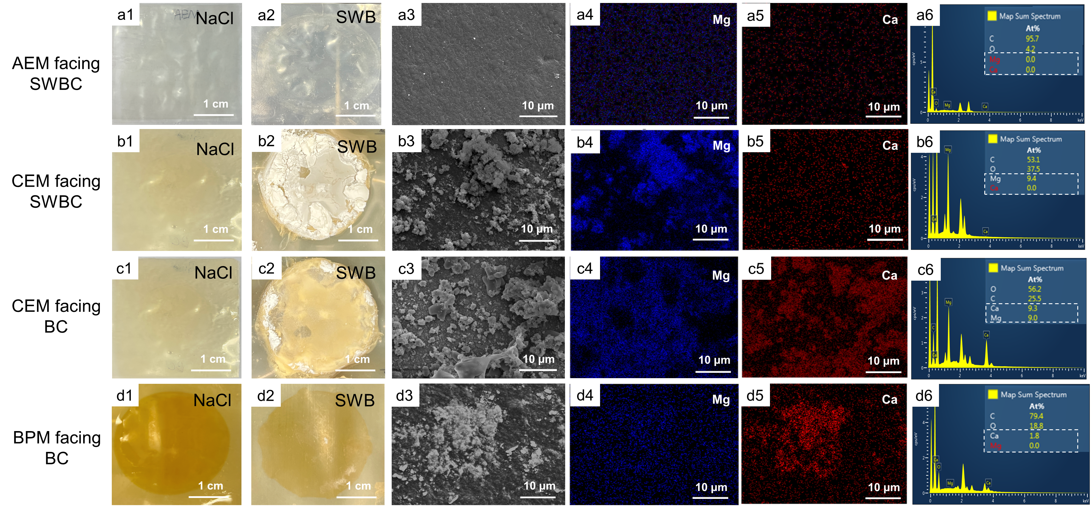

Figure 3 SEM and EDS elemental analysis of membrane surfaces. AEM facing SWBC: Photograph after tests in (a1) NaCl and (a2) SWB; (a3) SEM diagram; EDS elemental mapping image of (a4) Mg and (a5) Ca; (a6) EDS map spectrum. CEM facing SWBC: Photograph after tests in (b1) NaCl and (b2) SWB; (b3) SEM diagram; EDS elemental mapping image of (b4) Mg and (b5) Ca; (b6) EDS map spectrum. CEM facing BC: Photograph after tests in (c1) NaCl and (c2) SWB; (c3) SEM diagram; EDS elemental mapping image of (c4) Mg and (c5) Ca; (c6) EDS map spectrum. BPM facing BC: Photograph after tests in (d1) NaCl and (d2) SWB; (d3) SEM diagram; EDS elemental mapping image of (d4) Mg and (d5) Ca; (d6) EDS map spectrum. (AC: acid chamber; SWBC: seawater brine chamber; BC: base chamber).

XRD analysis was performed to identify the type of scaling (**Fig. S11**). Peaks appeared at about 18.6° (2θ) and a series of peaks (34.1°, 38°, 50.9°, 58.6°, 62°, 68.1°, 72°) within the following 2θ ranges were observed. This characterized the presence of Mg(OH)2 in the form of brucite crystals. It was consistent with the high concentration of Mg in elemental analysis of membrane surfaces (**Fig. 3 b6 c6**). The result of XRD also showed small amount of CaCO3 and Ca(OH)2. Peaks at about 29.4°, 35.9°, 39.4°, 43.1°, 47.5° and 48.5° (2θ) showed that CaCO3 precipitate in the form of calcite. As there was NaHCO3 in SWB, it reacted with OH- and transferred to CO32- in SWBC. CaCO3 was more likely to precipitate than Ca(OH)2 (Ksp = 4.7 × 10-9 for CaCO3 and Ksp = 1.3 × 10-5 for Ca(OH)2 48-50. The weak peaks in the XRD pattern (34.1°, 54.3° and 62.6°) also proved that the percentage of Ca(OH)2 was extremely low in the scaling. At the same time, the peak of NaCl was also observed. The existence of NaCl in the powder might be that NaCl was not completely dissolved during the cleaning process for XRD sample preparation. The above XRD results concluded that the scaling in BMED stack was composed of a large amount of Mg(OH)2 and small amount of CaCO3 and Ca(OH)2.

* 1. **Scaling mechanism in BMED**
     1. **Scaling formation in the stack**

In the BMED stack, scaling took place on membrane surface (**Fig. 3 a2 b2 c2 and d2**) in the bulk solution (**Fig. S6 b2**). **Fig. 4** illustrated the scaling in BMED stack. After tests, the total scaling gradually increased with time and increased by 97.2% (**Fig. 4a**). The scaling of Ca gradually increased to 40.56 mg. On the other hand, scaling of Mg was generated as soon as the experiment began. The final scaling of Mg reached 294.55 mg.

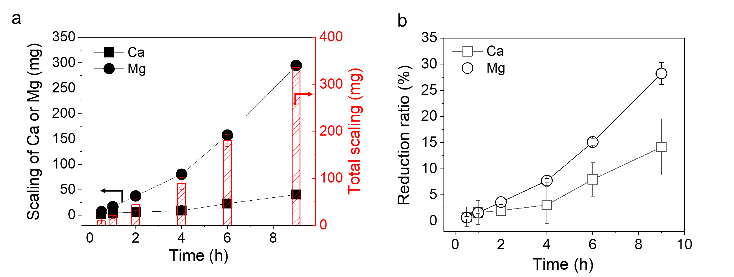

Figure 4 Quantification of scaling in BMED system. (a) The amount of scaling and (b) reduction ratio of Mg2+ and Ca2+ with time.

Scaling in the bulk solution can occur due to two main mechanisms. The first involved scaling that initially formed on the surface of IEMs and then detached into the bulk solution 35, 36. The fluctuation of voltage (**Fig. 2 b**) and membrane potential (**Fig. 2c**) illustrated the detachment and regrowth of scaling. The surface of IEMs was smooth and scaling growth on membrane surface. Scaling was easy to detach from the IEM surface, which resulted from the decrease of membrane potential and voltage. When a new scale layer grew, the potential difference increased again. Once the scaling shred from surface to the bulk solution, these particles not only contributed to visible turbidity but can also acted as nucleation seeds, accelerating further crystallization in the solution.

The second mechanism involved the direct crystallization within the bulk solution itself. When the location where the concentration of scaling ions (Ca2+, Mg2+, OH- and CO32-) exceeded their solubility limits was far away from the membrane, scaling was generated in the bulk solution36. After 4 hours, the accumulation of scaling ions in SWBC and BC enabled the scaling to form in chambers. In SWBC, the crystals continued to grow in the bulk solution at a relatively high concentration of OH- (**Fig. 2d**). From a kinetic point of view, the precipitation rate of Mg increased after 4 hours (**Fig. 4b**). The concentration of Mg in SWBC showed an increased rate of decline as well (**Fig. 5a**). These indicated that Mg-deposit formed in SWBC due to the high pH. Similarly, scaling also happened in the BC because the accumulation of Ca2+ and Mg2+ with time (**Fig. 5 b**). The concentration of Mg2+ remained low (0.06 to 0.12 mg/L) because it reacted with abundant OH- in BC as long as it transported across CEM. For Ca2+, it increased from 2.31 mg/L to 49.95 mg/L in 4 hours. In this period, Ca existed in the stack in ionic form. After 4 hours, the concentration of Ca sharply decreased (**Fig. 5b**) and the reduction ratio gradually increased (**Fig. 4b**), indicating the formation of Ca-deposit in BC.

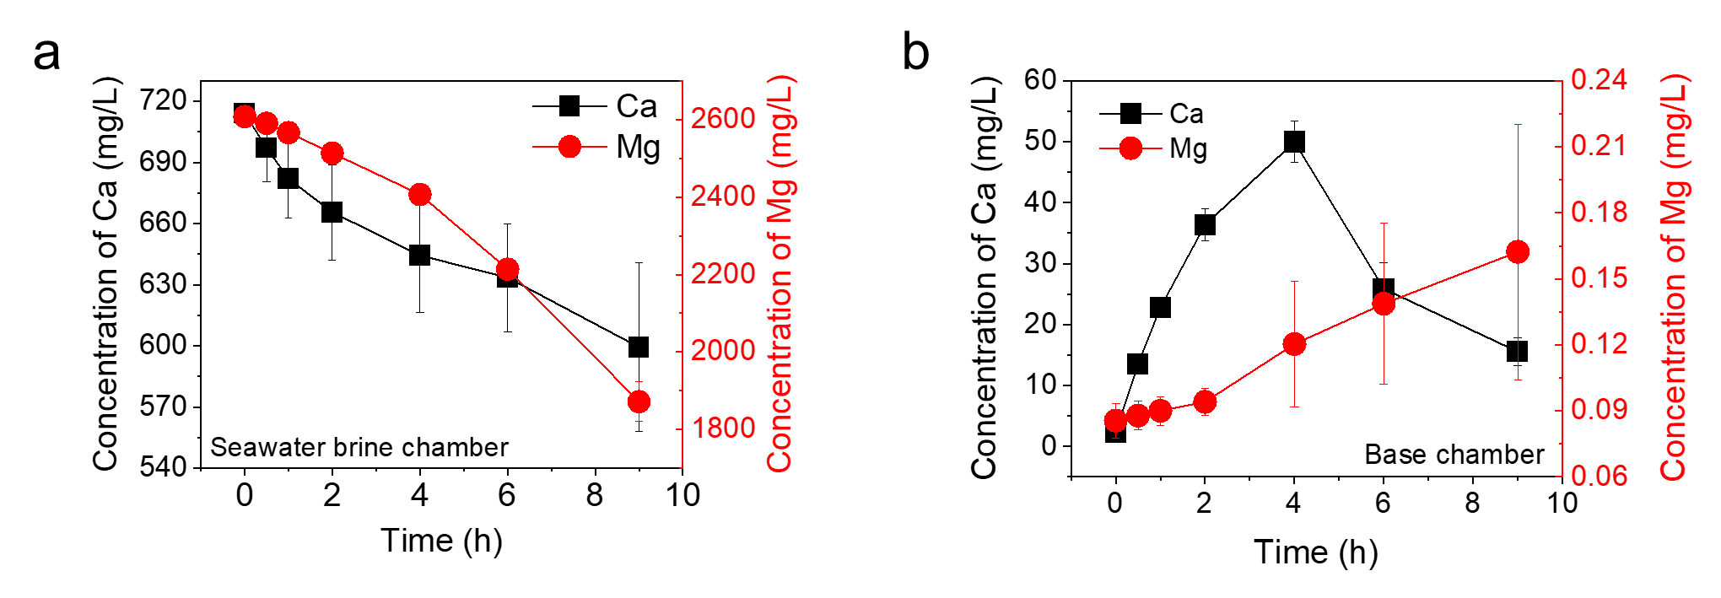

Figure 5 Concentration of Ca2+ and Mg2+ in the (a) SWBC and (b) BC.

* + 1. **Scaling formation on CEMs**

According to the membrane morphology detection, scaling would take place on both side of CEM. Each region demonstrated unique scaling behaviors influenced by local ion transport, OH⁻ generation and leakage. **Fig. 6** illustrated the scaling mechanisms.

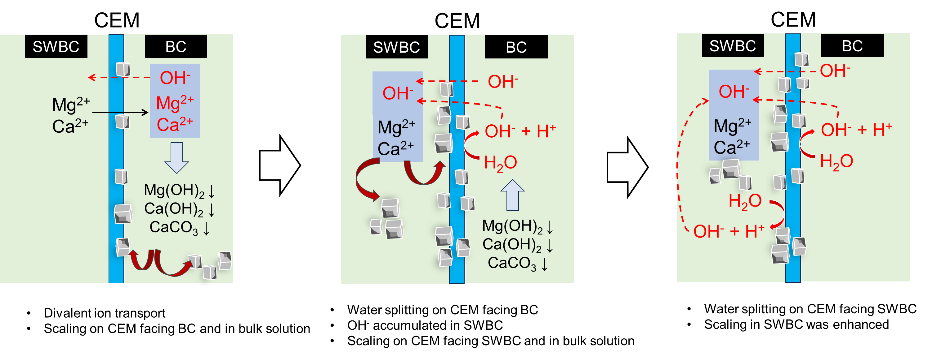

Figure 6 Schematic diagram of scaling formation mechanisms on CEM.

Once the test began, divalent ion transported from SWBC to BC (**Fig. 5 a b**) under the electric field. Once Mg2+ reached the BC, scaling of Mg was generated on CEM due to low solubility product, while Ca2+ was more likely to accumulate in the BC (**Fig. 5 b**). As scaling covered the membrane surface, the effective membrane area decreased and the local current density on the uncovered area increased 35, 39, 51, 52. The local overload made the system reach the limiting current state more quickly. When the local current density exceeded the limiting current density, water splitting occurred at the interface of membrane/salt solution35, 39, 52. The occurrence of water splitting generated H+ and OH- to carry current 39. OH- might leaked through CEM and accumulated in SWBC as OH- ions have an abnormally high mobility 53, 54. As shown in **Fig. 2 d**, pH of SWBC kept increasing. When pH of SWBC was near 9, the high concentration of Mg and Ca near CEM surface reacted with OH- to form precipitates. The scaling further decrease the effective membrane area and decrease the ion flux. In that case, water splitting happened on CEM facing SWBC 39, 52. OH- generated due to water splitting further accumulated in SWBC and reacted with abundant of divalent ions. Eventually, a large amount of scaling was formed on CEM surface and in the SWBC. Moreover, H+ generated by water splitting reached BC. It not only dissolved some of the precipitates , but also continuously reduced local pH near CEM facing BC to reduce the generation of scaling. Overall, water splitting enhanced the scaling on CEM facing SWBC, while relieved scaling on the other side, which was consistent with the morphology (**Fig. 3 b2 c2**)

Besides water splitting, the leakage of OH- from BC to SWBC was also a potential reason. **Fig. S14** showed the transport number of counter-ions of scaled CEM was 0.912, which was lower than that of pristine CEM. It indicated that scaling will change the permselectivity of CEM and increased the OH- leakage. The increase of leakage might result from the deformation of CEM. After the test, the membrane was not flat but concaved in the middle towards the chamber. It was likely that the scaling was attached to the membrane surface, causing uneven force on the entire membrane. The deformation of CEM might change the membrane structure and reduced its efficiency to prevent the leakage of OH-. Moreover, the decreased Donan exclusion might also increase the leakage. Gou, et al. 55 found that the high binding energy between Ca2+ and fixed charge group of CEM (RSO3-) enabled part of Ca2+ retained in the membrane channel. It was consistent with the result in **Fig. S14** that the transport number of CEM (Ca type) and CEM (Mg type) were a little lower than that of pristine CEM. When divalent ions retained in membrane channel. The fixed charges were occupied and the Donnan exclusion was weakened and enable the passage of co-ion (OH-) more easily. Although scaling usually grew on the surface of homogeneous CEMs, whether scaling grew in the membrane channel should be considered. The cross-section of scaled CEM and BPM (**Fig. S15**) was measured, and no obvious nanocrystal signal was detected under the scale of 1 μm. It may be necessary to use more sophisticated detection methods to observe whether this possibility exists, leading to deformation of the membrane channel.

* + 1. **Scaling formation on BPMs**

**Fig. 7** showed the scaling mechanism on BPM. For the BPM facing the BC, scaling was generated because generated high OH- concentration near its surface, creating localized high-pH conditions. Scaling on BPM was mostly composed of Ca2+ as shown in **Fig. 3 d3-d6**. Mg2+ and Ca2+ began to compete and form scaling on CEM surface when they reach BC through CEM. The low concentration of Mg in BC (**Fig. 5 b**) indicated that most of Mg reacted with OH- near the CEM surface and little Mg2+ could reach the bulk solution. On the contrary, most of Ca2+ could leave CEM surface (**Fig. 5 b**) and preferred to accumulate near BPM surface under electric field. In that case, Ca2+ combined with OH- on BPM surface to form a small amount of scaling.

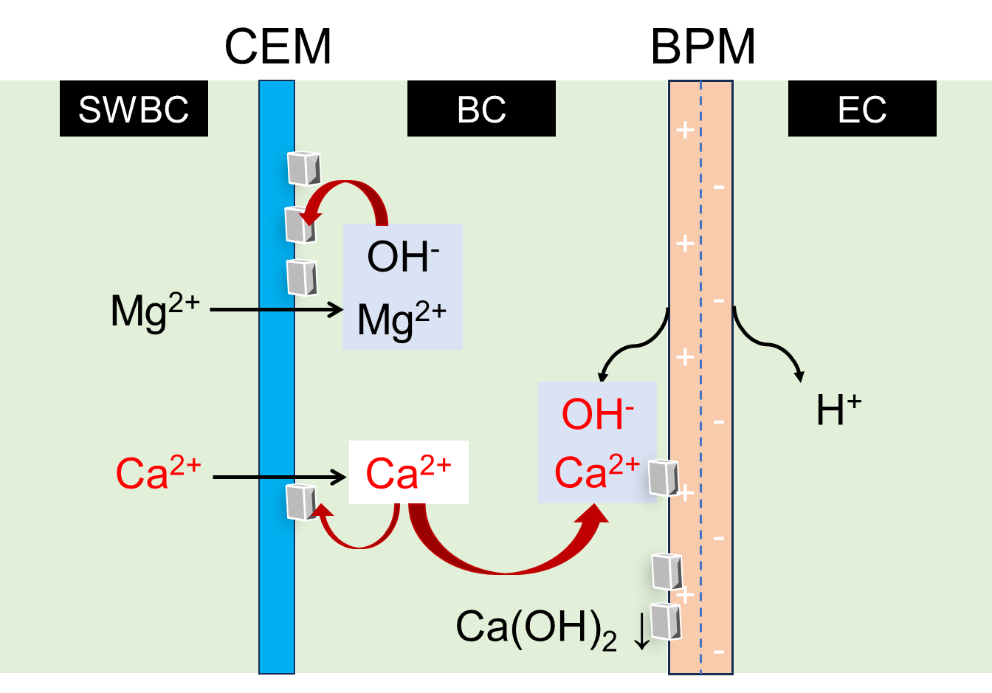

Figure 7 schematic diagram of scaling formation on BPM.

1. **Implication**

This study investigated scaling formation and its influence in BMED stack. It clarified the mechanisms of scaling in the bulk solution and on IEMs (both sides of CEM and BPM) during BMED process. Firstly, divalent ions transported through CEM under electric field and reached the BC. Most of Ca2+ reached BC and accumulated near BPM surface where localized high-pH conditions attributed to the scaling on BPM. Mg2+ reacted with abundant OH- near CEM facing BC to form precipitates. Secondly, the scaling reduced effective membrane surface and led to water splitting. OH- from water splitting resulted in scaling on CEM facing SWBC, where water splitting occurred on CEM facing SWBC as well. In the final stage, OH- accumulated in the SWBC resulting in the more severe scaling, while H+ transported to BC to relieve scaling formation in BC.

With the clarification of scaling formation mechanisms in BMED, it is essential to mitigate scaling in the BMED stack for acid and base production with seawater brine. Precipitates formation and large aggregation on the membranes should be avoided. On one hand, the transport of divalent ions through CEM, which is root of scaling, should be avoided to form precipitates in the first step. Then, a lower current density may prevent water splitting on both side of CEM. On the other hand, removing scaling on IEMs periodically can prevent water splitting and further deterioration of scaling. It is practical to use selective IEMs with high permselectivity to reduce the transport of divalent ions. The use of antiscalant and periodic cleaning could prevent the formation and accumulation of scaling in the stack. Further research are needed to mitigate BMED scaling when treating water with high divalent ions.

**Reference**

1. Guo, L.; Xie, Y.; Sun, W.; Xu, Y.; Sun, Y., Research progress of high-salinity wastewater treatment technology. *Water* **2023,** *15*, (4), 684.

2. Rehman, Z.; Mushtaq, A., Advancements in Treatment of High-Salinity Wastewater: A Critical. *Int. J. Chem. Biochem. Sci* **2023,** *23*, 1-10.

3. Mohammed, A. S.; Kapri, A.; Goel, R., Heavy metal pollution: source, impact, and remedies. *Biomanagement of metal-contaminated soils* **2011**, 1-28.

4. Capodici, M.; Cosenza, A.; Di Bella, G.; Di Trapani, D.; Viviani, G.; Mannina, G., High salinity wastewater treatment by membrane bioreactors. *Current developments in biotechnology and bioengineering* **2020**, 177-204.

5. Kabir, M. M.; Sabur, G. M.; Akter, M. M.; Nam, S. Y.; Im, K. S.; Tijing, L.; Shon, H. K., Electrodialysis desalination, resource and energy recovery from water industries for a circular economy. *Desalination* **2024,** *569*.

6. Dolnicar, S.; Schafer, A. I., Desalinated versus recycled water: public perceptions and profiles of the accepters. *J Environ Manage* **2009,** *90*, (2), 888-900.

7. Valero, F.; Barceló, A.; Arbós, R., Electrodialysis technology: theory and applications. *Desalination, trends and technologies* **2011,** *28*, 3-20.

8. Strathmann, H., Electrodialysis, a mature technology with a multitude of new applications. *Desalination* **2010,** *264*, (3), 268-288.

9. Xu, T.; Huang, C., Electrodialysis‐based separation technologies: a critical review. *AIChE journal* **2008,** *54*, (12), 3147-3159.

10. Huang, C.; Xu, T., Electrodialysis with bipolar membranes for sustainable development. *Environmental science & technology* **2006,** *40*, (17), 5233-5243.

11. Zhang, X.; Lu, W.; Ren, H.; Cong, W., Sulfuric acid and ammonia generation by bipolar membranes electrodialysis: Transport rate model for ion and water through anion exchange membrane. *Chemical and Biochemical Engineering Quarterly* **2008,** *22*, (1), 1-8.

12. Luo, Y.; Liu, Y.; Shen, J.; Van der Bruggen, B., Application of bipolar membrane electrodialysis in environmental protection and resource recovery: a review. *Membranes* **2022,** *12*, (9), 829.

13. Ghyselbrecht, K.; Huygebaert, M.; Van der Bruggen, B.; Ballet, R.; Meesschaert, B.; Pinoy, L., Desalination of an industrial saline water with conventional and bipolar membrane electrodialysis. *Desalination* **2013,** *318*, 9-18.

14. Reig, M.; Valderrama, C.; Gibert, O.; Cortina, J. L., Selectrodialysis and bipolar membrane electrodialysis combination for industrial process brines treatment: Monovalent-divalent ions separation and acid and base production. *Desalination* **2016,** *399*, 88-95.

15. Zhao, W.-Y.; Zhou, M.; Yan, B.; Sun, X.; Liu, Y.; Wang, Y.; Xu, T.; Zhang, Y., Waste conversion and resource recovery from wastewater by ion exchange membranes: state-of-the-art and perspective. *Industrial & Engineering Chemistry Research* **2018,** *57*, (18), 6025-6039.

16. Shi, L.; Xiao, L.; Hu, Z.; Zhan, X., Nutrient recovery from animal manure using bipolar membrane electrodialysis: Study on product purity and energy efficiency. *Water Cycle* **2020,** *1*, 54-62.

17. Lameloise, M.-L.; Lewandowski, R., Recovering l-malic acid from a beverage industry waste water: Experimental study of the conversion stage using bipolar membrane electrodialysis. *Journal of Membrane Science* **2012,** *403-404*, 196-202.

18. Erkmen, J.; Yapıcı, S.; Arzutuğ, M. E.; Aydın, Ö.; Ata, O. N.; Öner, M. R., Hydrofluoric acid and sodium hydroxide production by bipolar membrane electrodialysis. *Desalination and Water Treatment* **2016,** *57*, (43), 20254-20260.

19. Qiu, Y.; Yao, L.; Tang, C.; Zhao, Y.; Zhu, J.; Shen, J., Integration of selectrodialysis and selectrodialysis with bipolar membrane to salt lake treatment for the production of lithium hydroxide. *Desalination* **2019,** *465*, 1-12.

20. Kishida, M.; Harato, T.; Tokoro, C.; Owada, S., In situ remediation of bauxite residue by sulfuric acid leaching and bipolar-membrane electrodialysis. *Hydrometallurgy* **2017,** *170*, 58-67.

21. Trivedi, G.; Shah, B.; Adhikary, S.; Rangarajan, R., Studies on bipolar membranes: Part III: Conversion of sodium phosphate to phosphoric acid and sodium hydroxide. *Reactive and Functional Polymers* **1999,** *39*, (1), 91-97.

22. Trivedi, G.; Shah, B.; Adhikary, S.; Indusekhar, V.; Rangarajan, R., Studies on bipolar membranes. Part II—Conversion of sodium acetate to acetic acid and sodium hydroxide. *Reactive and Functional Polymers* **1997,** *32*, (2), 209-215.

23. Tongwen, X.; Weihua, Y., Citric acid production by electrodialysis with bipolar membranes. *Chemical Engineering and Processing: Process Intensification* **2002,** *41*, (6), 519-524.

24. Wei, Y.; Li, C.; Wang, Y.; Zhang, X.; Li, Q.; Xu, T., Regenerating sodium hydroxide from the spent caustic by bipolar membrane electrodialysis (BMED). *Separation and Purification Technology* **2012,** *86*, 49-54.

25. Ren, H.; Wang, Q.; Zhang, X.; Kang, R.; Shi, S.; Cong, W., Membrane fouling caused by amino acid and calcium during bipolar membrane electrodialysis. *Journal of Chemical Technology & Biotechnology* **2008,** *83*, (11), 1551-1557.

26. Tran, A. T.; Jullok, N.; Meesschaert, B.; Pinoy, L.; Van der Bruggen, B., Pellet reactor pretreatment: a feasible method to reduce scaling in bipolar membrane electrodialysis. *J Colloid Interface Sci* **2013,** *401*, 107-15.

27. Wang, Q.; Yang, P.; Cong, W., Cation-exchange membrane fouling and cleaning in bipolar membrane electrodialysis of industrial glutamate production wastewater. *Separation and Purification Technology* **2011,** *79*, (1), 103-113.

28. Chang, J.-H.; Ellis, A. V.; Tung, C.-H.; Huang, W.-C., Copper cation transport and scaling of ionic exchange membranes using electrodialysis under electroconvection conditions. *Journal of Membrane Science* **2010,** *361*, (1-2), 56-62.

29. Al-Amoudi, A.; Lovitt, R. W., Fouling strategies and the cleaning system of NF membranes and factors affecting cleaning efficiency. *Journal of membrane science* **2007,** *303*, (1-2), 4-28.

30. Bazinet, L.; Montpetit, D.; Ippersiel, D.; Amiot, J.; Lamarche, F., Identification of skim milk electroacidification fouling: a microscopic approach. *Journal of colloid and interface science* **2001,** *237*, (1), 62-69.

31. Casademont, C.; Farias, M.; Pourcelly, G.; Bazinet, L., Impact of electrodialytic parameters on cation migration kinetics and fouling nature of ion-exchange membranes during treatment of solutions with different magnesium/calcium ratios. *Journal of Membrane Science* **2008,** *325*, (2), 570-579.

32. Mehran Aliaskari, H. H., Florencia Saravia, Real Time Monitoring of Scaling Behavior in Bipolar Membrane Electrodialysis. *Journal of Membrane Science* **2025**.

33. Lin Teng Shee, F.; Arul, J.; Brunet, S.; Bazinet, L., Chitosan solubilization by bipolar membrane electroacidification: Reduction of membrane fouling. *Journal of Membrane Science* **2007,** *290*, (1-2), 29-35.

34. Andreeva, M. A.; Gil, V. V.; Pismenskaya, N. D.; Nikonenko, V. V.; Dammak, L.; Larchet, C.; Grande, D.; Kononenko, N. A., Effect of homogenization and hydrophobization of a cation-exchange membrane surface on its scaling in the presence of calcium and magnesium chlorides during electrodialysis. *Journal of Membrane Science* **2017,** *540*, 183-191.

35. Asraf-Snir, M.; Gilron, J.; Oren, Y., Scaling of cation exchange membranes by gypsum during Donnan exchange and electrodialysis. *Journal of Membrane Science* **2018,** *567*, 28-38.

36. Andreeva, M. A.; Gil, V. V.; Pismenskaya, N. D.; Dammak, L.; Kononenko, N. A.; Larchet, C.; Grande, D.; Nikonenko, V. V., Mitigation of membrane scaling in electrodialysis by electroconvection enhancement, pH adjustment and pulsed electric field application. *Journal of Membrane Science* **2018,** *549*, 129-140.

37. Reig, M.; Casas, S.; Gibert, O.; Valderrama, C.; Cortina, J. L., Integration of nanofiltration and bipolar electrodialysis for valorization of seawater desalination brines: Production of drinking and waste water treatment chemicals. *Desalination* **2016,** *382*, 13-20.

38. Cassaro, C.; Virruso, G.; Culcasi, A.; Cipollina, A.; Tamburini, A.; Micale, G., Electrodialysis with bipolar membranes for the sustainable production of chemicals from seawater brines at pilot plant scale. *ACS Sustainable Chemistry & Engineering* **2023,** *11*, (7), 2989-3000.

39. Liu, H.; She, Q., Scaling-Enhanced Scaling during Electrodialysis Desalination. *ACS ES&T Engineering* **2024,** *4*, (5), 1063-1072.

40. Chen, B.; Jiang, C.; Wang, Y.; Fu, R.; Liu, Z.; Xu, T., Selectrodialysis with bipolar membrane for the reclamation of concentrated brine from RO plant. *Desalination* **2018,** *442*, 8-15.

41. Dlugolecki, P.; Nymeijer, K.; Metz, S.; Wessling, M., Current status of ion exchange membranes for power generation from salinity gradients. *Journal of Membrane Science* **2008,** *319*, (1-2), 214-222.

42. Han, L.; Galier, S.; Roux-de Balmann, H., Ion hydration number and electro-osmosis during electrodialysis of mixed salt solution. *Desalination* **2015,** *373*, 38-46.

43. Cassaro, C.; Virruso, G.; Culcasi, A.; Cipollina, A.; Tamburini, A.; Micale, G., Electrodialysis with Bipolar Membranes for the Sustainable Production of Chemicals from Seawater Brines at Pilot Plant Scale. *ACS Sustain Chem Eng* **2023,** *11*, (7), 2989-3000.

44. Luo, Y.; Liu, Y.; Shen, J.; Van der Bruggen, B., Application of Bipolar Membrane Electrodialysis in Environmental Protection and Resource Recovery: A Review. *Membranes (Basel)* **2022,** *12*, (9).

45. Zou, G.; Chen, W.; Liu, R.; Xu, Z., Morphology-tunable synthesis and characterizations of Mg(OH)2 films via a cathodic electrochemical process. *Materials Chemistry and Physics* **2008,** *107*, (1), 85-90.

46. Beck, R.; Andreassen, J. P., Influence of crystallization conditions on crystal morphology and size of CaCO3 and their effect on pressure filtration. *AIChE Journal* **2011,** *58*, (1), 107-121.

47. <Morphology and Structure of CaCO3 Scale Layers Formed under Isothermal Flow Conditions.pdf>.

48. Fan, C.; Chen, J.; Chen, Y.; Ji, J.; Teng, H. H., Relationship between solubility and solubility product: The roles of crystal sizes and crystallographic directions. *Geochimica et Cosmochimica Acta* **2006,** *70*, (15), 3820-3829.

49. Johnston, J., THE SOLUBILITY-PRODUCT CONSTANT OF CALCIUM AND MAGNESIUM CARBONATES. *Journal of the American Chemical Society* **1915,** *37*, (9), 2001-2020.

50. Cao, X.; Harris, W., Carbonate and magnesium interactive effect on calcium phosphate precipitation. *Environmental science & technology* **2008,** *42*, (2), 436-442.

51. Shaposhnik, V.; Zubets, N.; Strygina, I.; Mill, B., High demineralization of drinking water by electrodialysis without scaling on the membranes. *Desalination* **2002,** *145*, (1-3), 329-332.

52. Belashova, E.; Mikhaylin, S.; Pismenskaya, N.; Nikonenko, V.; Bazinet, L., Impact of cation-exchange membrane scaling nature on the electrochemical characteristics of membrane system. *Separation and Purification Technology* **2017,** *189*, 441-448.

53. Lorrain, Y.; Pourcelly, G.; Gavach, C., Influence of cations on the proton leakage through anion-exchange membranes. *Journal of membrane science* **1996,** *110*, (2), 181-190.

54. Agmon, N., Mechanism of hydroxide mobility. *Chemical Physics Letters* **2000,** *319*, (3-4), 247-252.

55. Gou, M.; Zhao, Y.; Li, B.; Li, Y.; Li, Z.; Wang, M., Scaling behavior of cation exchange membrane induced by Ca2+ during the electrodialysis for enriching lithium-containing solutions. *Journal of Membrane Science* **2025,** *713*.